hChoices Website
Logging Wellness Challenge Points
LOGIN:
- hChoices website at: https://hchoices.com
- Click [Login] – top right hand corner
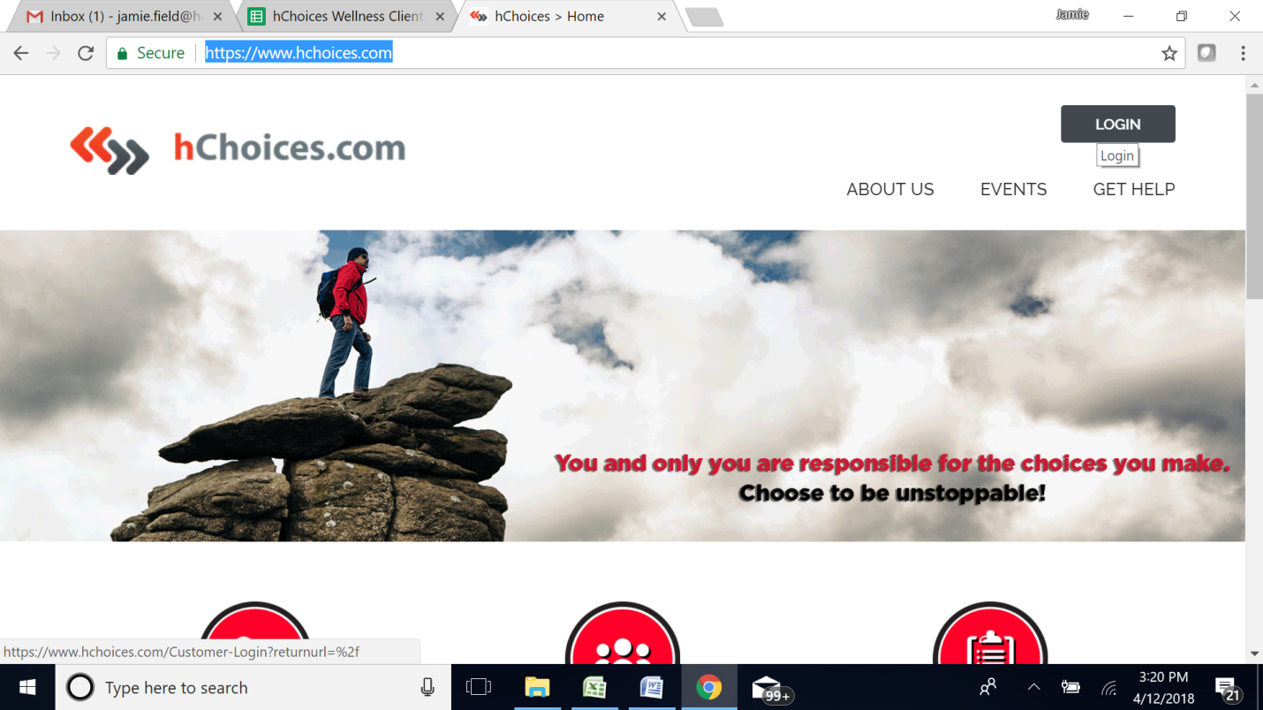
- Enter username
- Enter password
- Click [Login]
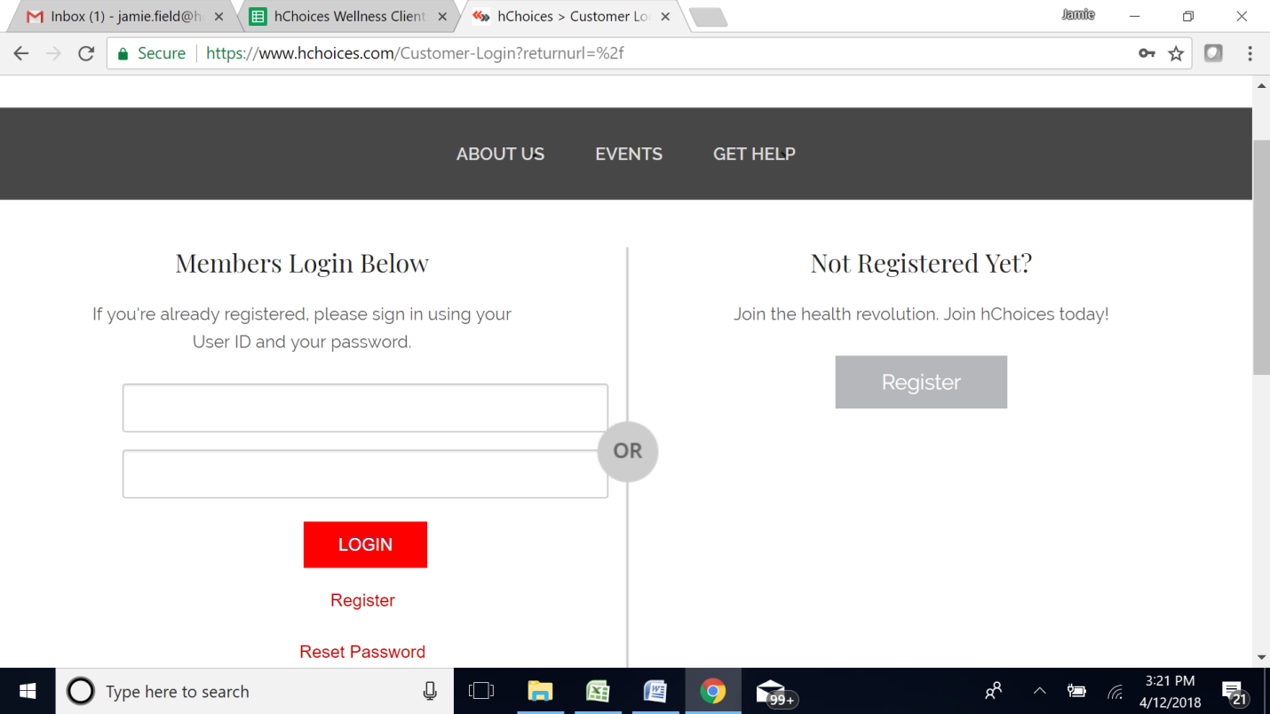

- Click [My Dashboard]
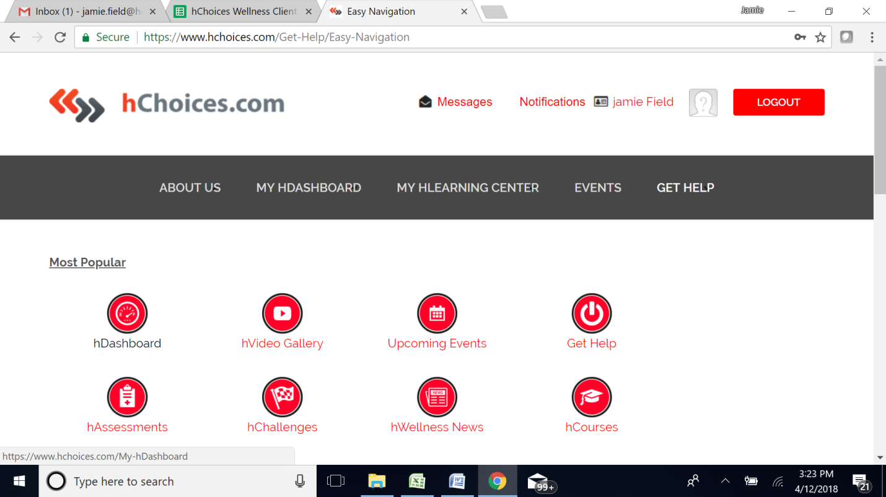

- Click [Challenges]
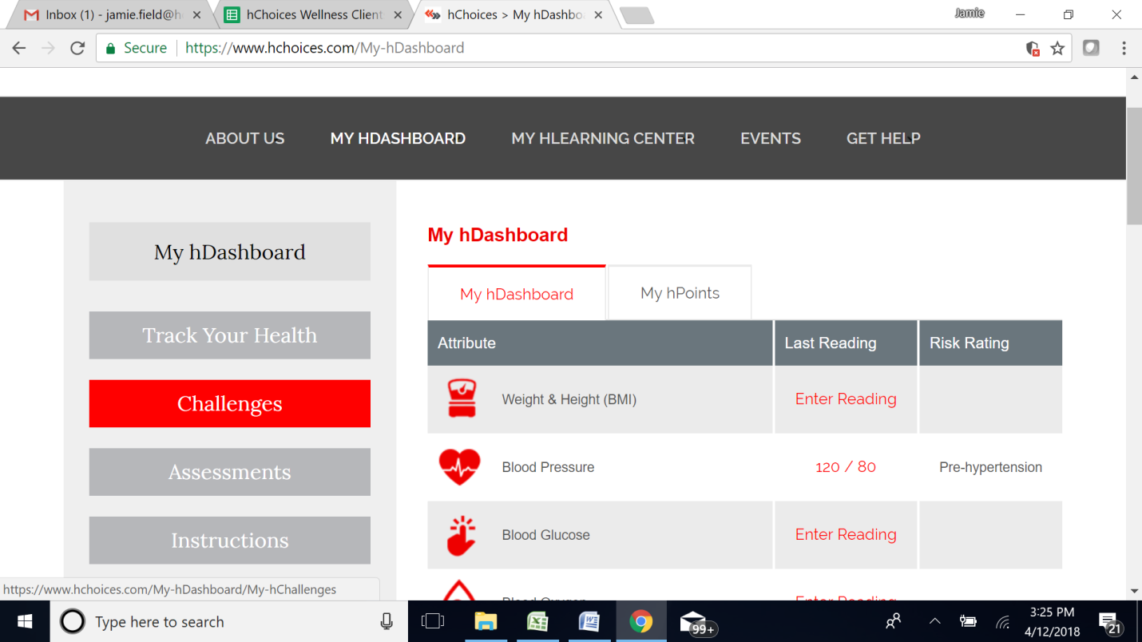

- Pick Challenge to enter points - If first time joining skip to #9
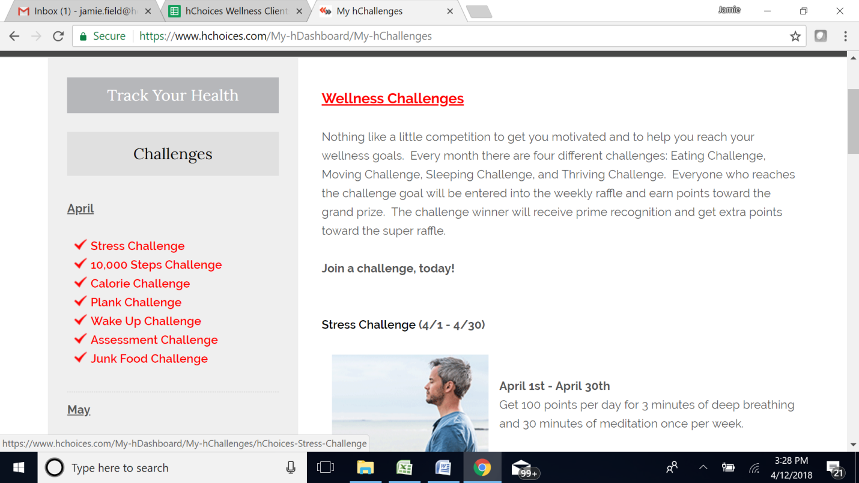
- Join a Challenge:
Select Team from drop down box
Click [I Accept]
Click [Take Challenge]
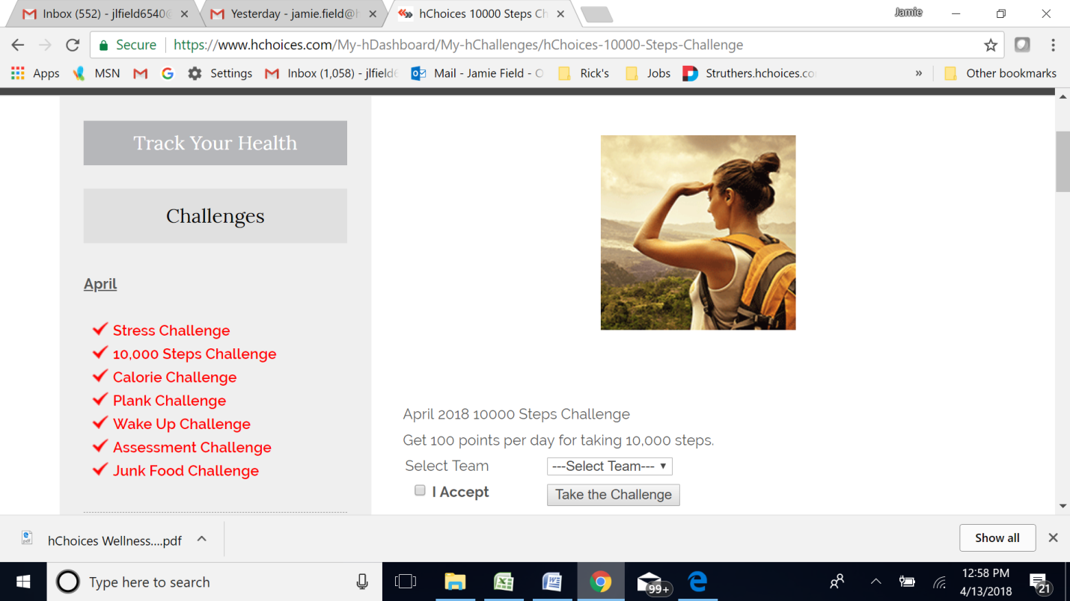

- Enter Points Click [Submit]
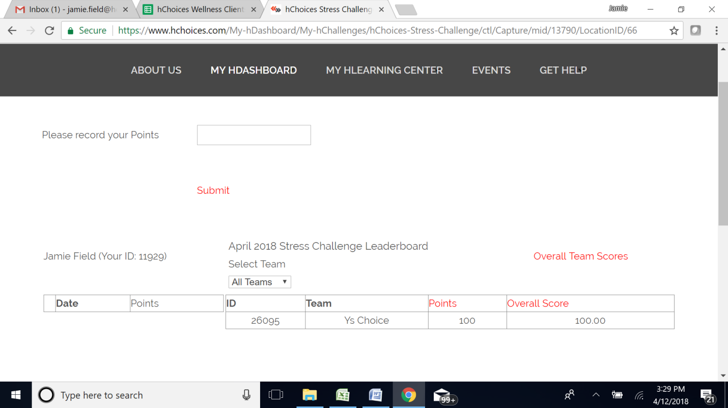

logging points:
Example: “Minutes of Exercise” is 10 points per day – entering 1 day
Enter: 10 Points
Example: “Minutes of Exercise” is 10 points per day – entering 5 days
Enter: 50 points
*** Each Challenge you will need to log separate under the correct challenge completed.
Questions:
Please contact Jamie Field 216-509-6540 or Jamie.field@hchoices.com

